National University of Computer and Emerging Sciences



Lab Manual # 09

Programming Fundamentals

|  |  |
| --- | --- |
| Course Instructor | Dr. Amir Wali |
| Lab Instructor(s) | Arfa Masood  Hira Butt |
| Section | 1B |
| Semester | Fall 2022 |

Department of Computer Science

FAST-NU, Lahore, Pakistan

**Instructions:**

* Do your tasks individually
* Anyone indulged in the act of plagiarism would be awarded zero
* Pay attention to details, do paper work before starting your code
* Understanding of the question is also part of the lab work

**Objectives:**

In this lab, students will study:

* 1D Arrays
* Character Arrays
* 2D Arrays

**Task 1:** Write a function that returns an integer and accepts a fixed size character array as an argument. The function should count the number of characters in the character array and return that number. Demonstrate the function in a simple program that asks the user to input a string, passes it to the function, and then displays the function’s return value.

Example:

Input:

Enter a sentence: Hi how are you?

Output:

Total characters are: 12

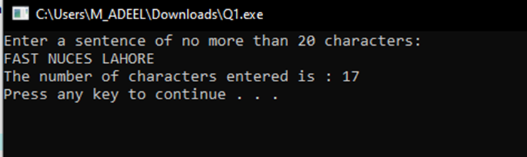

**Task 2:** Write a C++ program to read a sentence from console into a character array (not more than length of 100 characters). Now separate each word and find the word with minimum length and display it on screen. You also have to make integer array to store length of each word in sentence. Your code should be generic

Sample Input

Summer Vacations are canceled this year.

Sample Output

6 9 3 8 4 4

Min: 3

**\*Note:** Your sentence always ends with full stop.

**Task 3:** Write a program that takes two inputs from the user. The 1st input will be a character. While the 2nd input will be a fixed size character array. Your program must now delete the character from the character array and displays the updated char array on the screen.

**Input:**

Enter a character: a

Enter a sentence:What is your name

**Output:**

Wht is your nme

**Hint:** You must use cin.ignore() after single character input and cin.getline() for char array. Do it without cin.ignore() and see the buffer blunder by yourself.

**Task 4:** Write a C++ program that reads text (character data) from the user. Words in the input array are separated by white spaces. The program should reverse each word and save them (the new sentence) in an array.

**Sample Input/Output:**

Original text: A BOY WAS STANDING ON THE WALL

Array of Reversed words: A YOB SAW GNIDNATS NO EHT LLAW

**Task 5:** Write a program to add 2 matrices (2 dimensional arrays) of size 3 or 4. Input order of matrix (i.e. number of rows and columns). The matrices must be of the same size to be added. Get the input for each element of the first matrix and then the second matrix. Add the two matrices and store the values in third matrix. Finally display all matrices.